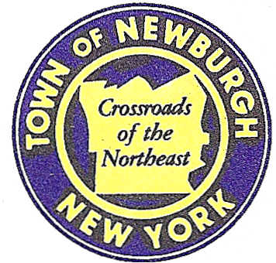

TOWN OF NEWBURGH
_______Crossroads of the Northeast __________________________
OLD TOWN HALL
308 GARDNERTOWN ROAD NEWBURGH, NEW YORK 12550

PLANNING BOARD
JOHN P. EWASUTYN, CHAIRMAN
TELEPHONE 845-564-7804
FAX 845-564-7802
E-MAIL: planningboard@townofnewburgh.org

PLANNING BOARD AGENDA

September 5th, 2019

*PLEASE NOTE: The Planning Board Meeting will start at 7:00 P.M. and all Applicants/Representatives
are to be present at that time. The Meeting will be held in the Meeting Room of Town Hall,
located at 1496 Route 300, Newburgh NY.*

- BJ’s Wholesale Club- Newburgh( (19-07) SHOPPING CENTER/MIXED USE
NYS Route 17K & Auto Park Place SITE PLAN
Section 97, Block 2, Lot 44, 46.2 & 45
Zone: IB
Rep: Maser Consulting, P.A.
555 Hudson Valley Ave. Suite 101
New Windsor, NY 12553

- Serviss (19-10) 4 LOT SUBDIVISION
Easterly side of Union Ave.
Section 34, Block 1, Lot 25.2
Zone: R-2
Rep: James A. Dillin, PLS
38 Scotchtown Ave.
Goshen, NY 10924

- 349 South Plank Road (19-12) SITE PLAN
349 South Plank Road
Section 47, Block 1 Lot 80.1
Zone: B
Rep: Jonathan Cella, P.E.
51 Hunt Road
Wallkill, NY 12589

*WORK SESSION*
Project Readiness Discussion scheduled for 5:30 p.m. in the Meeting Room of
Town Hall on Thursday, September 5th, 2019*

- 11 Balmville Road (19-17)
11 Balmville Road AMENDED SITE PLAN
Section 84, Block 5, Lot 26
Zone: 04
Rep: Engineering & Surveying Properties, PC/Ross Winglovitz
71 Clinton Street
Montgomery, NY 12549

PLANNING BOARD BUSINESS
WORK SESSION

*WORK SESSION*
Project Readiness Discussion scheduled for 5:30 p.m. in the Meeting Room of
Town Hall on Thursday, September 5th, 2019.*

